Let  be the head achieved by the pump. A linear map is defined between head, the pressure rise across the pump, and the PWM duty cycle,

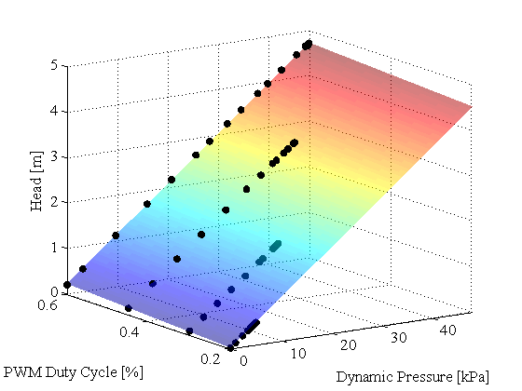

where  is in Pascals and . Using data collected from the experimental system, a least squares fit gives us,

  
  


This map is plotted in the figure to the right. The maximum error between the raw data and the generated map is 0.0225, which is 0.48%.

Flow rate through the centrifugal pump can be calculated,



where  is the gravitational constant,  is the density of the fluid moving through the pump, and  is the area at the exit of the pump. Doing a parameter sweep across  and , the map in the figure below was generated. The black dots represent the actual data.

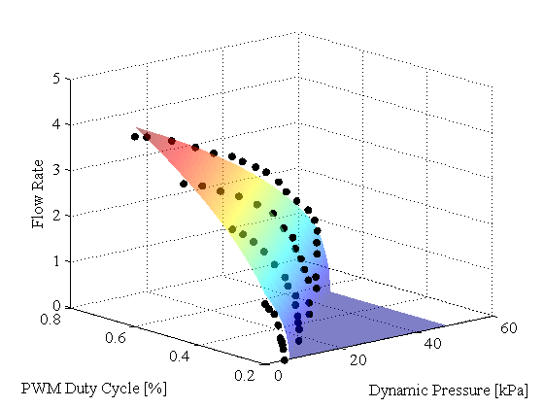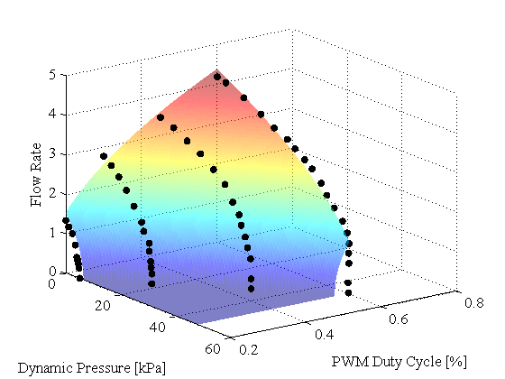

The efficiency of the pump is determined using a quadratic surface estimated by the following equation,



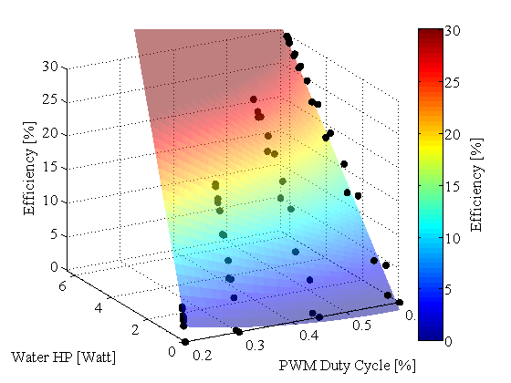where  is calculated by,

.

Using least squares, the constants are identified as,

  
  
  
  
  


By sweeping parameters, the map on the right is generated.

Constants used:



The pump map is saved as ***PumpProp.mat***